**Lab Practical #07:**

Implement the various network protocols - DNS

**Practical Assignment #07:**

Implement the application protocol - DNS using packet tracer.

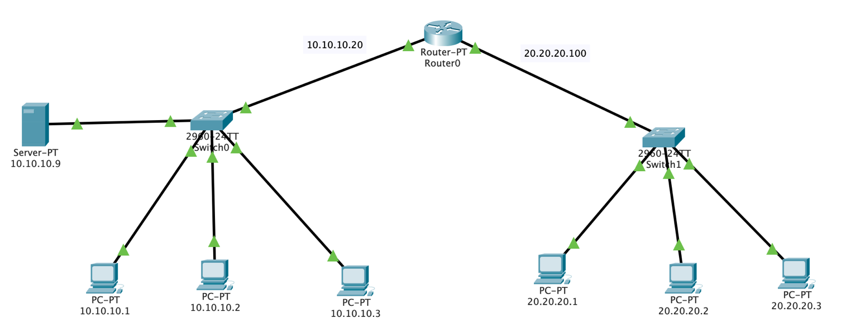

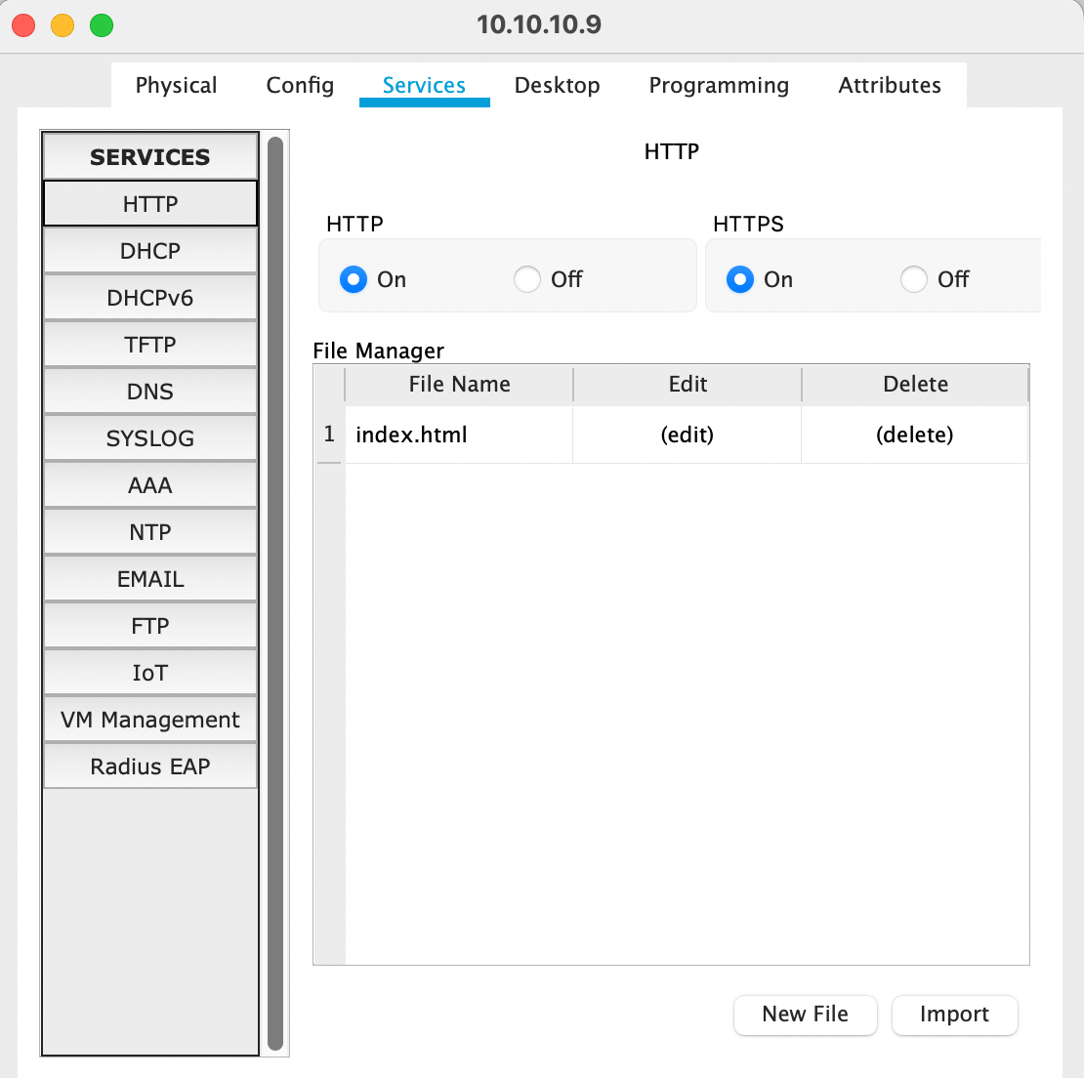

http Configuration

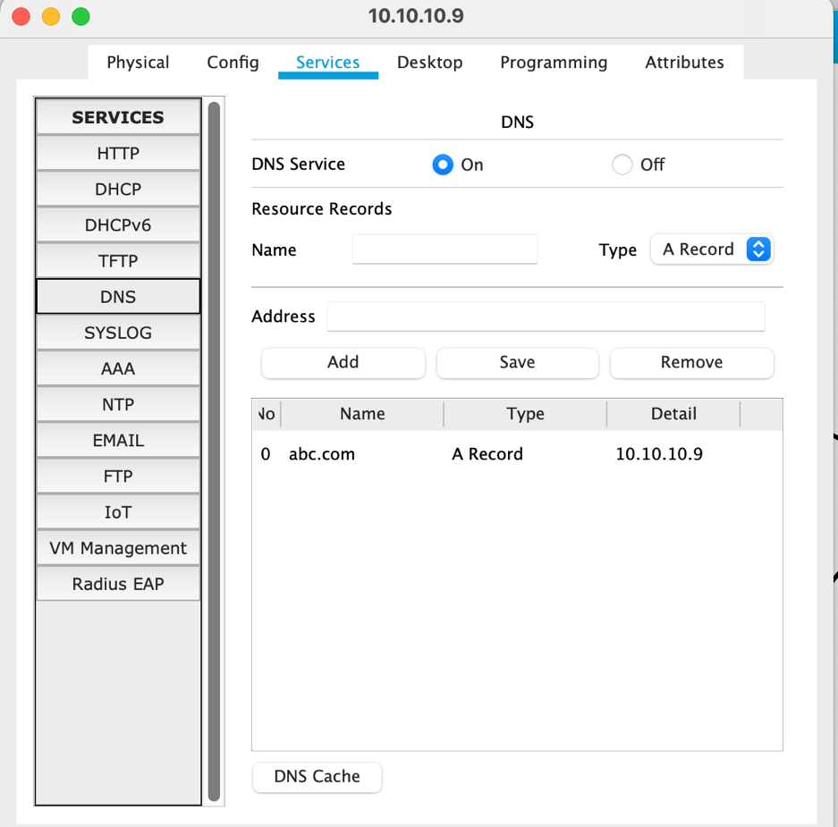

DNS Configuration

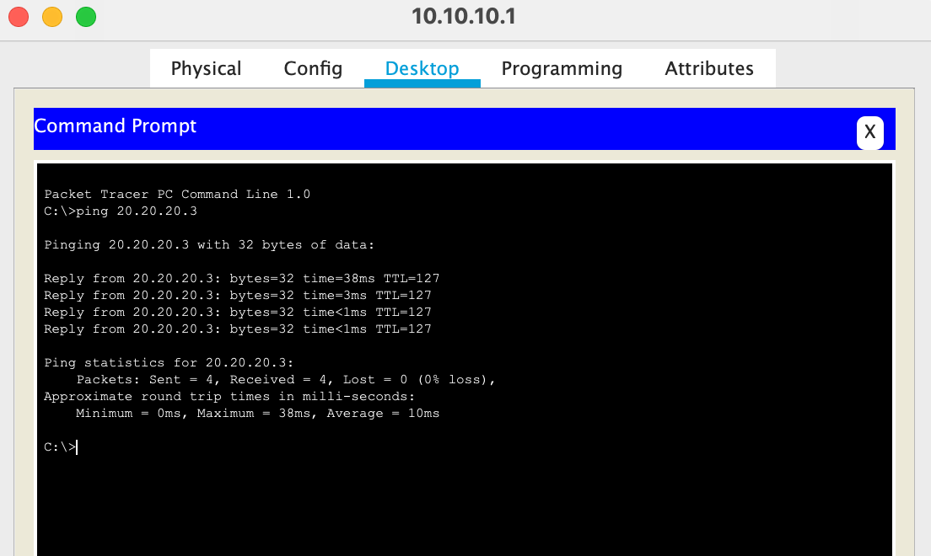

Pnig from 10.10.10.1 to 20.20.20.3